# 10.0.0 Assessment Task 5

Group 2 Presentation

Storyboard & Script (Draft)

# Draft Storyboard

# Draft Scenes

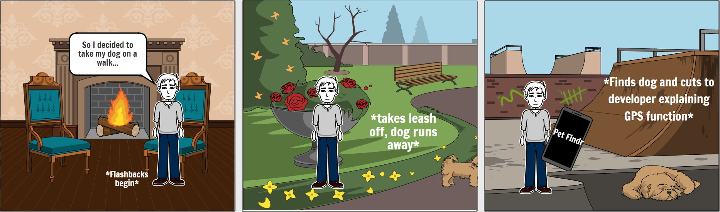

____________________ ____________________ ____________________

____________________ ____________________ ____________________

____________________ ____________________ ____________________

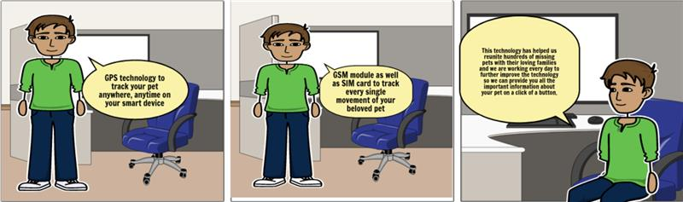

____________________ ____________________ ____________________

____________________ ____________________ ____________________

____________________ ____________________ ____________________

____________________ ____________________ ____________________

____________________ ____________________ ____________________

____________________ ____________________ ____________________

____________________ ____________________ ____________________

____________________ ____________________ ____________________

____________________ ____________________ ____________________

____________________ ____________________ ____________________

____________________ ____________________ ____________________

____________________ ____________________ ____________________

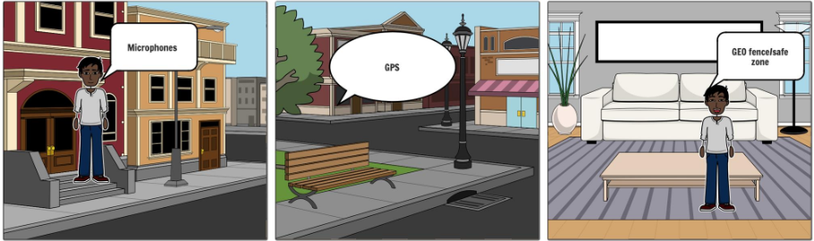

____________________ ____________________ ____________________

____________________ ____________________ ____________________

____________________ ____________________ ____________________

# Draft Script

**Introduction**

Find My Phone helps you locate your lost Smartphone and get it back, our PetTrackr app is based on the same concept, but uses google maps and Global Positioning System (GPS) technology for real-time or live tracking and seeing location activity, giving you the ability to track your pet and manage your notification settings from anywhere in the world.

*\*cut to Mark explaining the GPS \**

**Storyboard > Mark George**



**Draft Script**

“I wanted to take my dog on a walk”

*flashback to walk*

“Since she puts a lot of trust in me, I wanted to put some trust in her… so I let her leash go”

*flashback to dog running away*

“I looked EVERYWHERE, I ran across my whole city and I couldn’t find her”

*flashback to me running*

“I lost all hope… then I remembered I had just bought Pet Findr, I pulled out the app, and there she was!”

*\*cut to Kanav explaining the GPS features\**

**Storyboard > Kanav Atri**



**Draft Script**

At pet-finders we understand the bond that you have with your pet and its natural to feel fear of losing a beloved family pet.

Our GPS tracking system is capable of tracking the exact location of your pet in real time. Our GPS tracker can easily be attached to the collar of your pet and it can generate real time data which can be viewed anytime by simply logging into the app on your phone or any other smart device. We use state of the art cutting edge technology and GSM module as well as SIM card to track every single movement of your beloved pet. The GPS system can also detect if your pets leave the set safe zone and can send a notification straight to your phone.

This technology has helped us reunite hundreds of missing pets with their loving families and we are working every day to further improve the technology so we can provide you all the important information about your pet on a click of a button.

*cut to Victor explaining Pet health and safety*

**Storyboard > Victor van der Meer**

**Draft Script**

**Introduction**

Hi, my name is Victor,  
  
I am a fan of cats! I have two, and they are members of my family; I love the companionship and joy they bring into my life. Now, I cannot imagine what life would be like without them!

**Problem**  
  
During the COVID-19 lockdown, my cats were my rock. One of my cats became ill and was vomiting up his food.   
  
I spent a lot of money on vet bills only to be told all I could do was monitor his drink and food intake or pay to do more tests.

**Solution**  
  
The PetFindr is not only a GPS Tracking System, but a health app for pets designed to monitor your pet’s heart rate, exercise routines and daily food intake. Information is stored securely on the cloud and gives you the ability to share this data with your vet, if required. With a built-in barcode scanner, you can also record brands and nutrition information at the click of a finger.

*cut to Matthew explaining Pet health and safety feature*

**Storyboard > Matthew Ahearn**

**Draft Script**

Do you want to make sure you are taking the best care of your furry best friend? Are you tired of expensive visits to the vet that stress your pet? Now you can have the piece of mind you deserve with the Petfindr.

While helping you keep track of your pet and keeping you safe from pet thieves and loosing your pet the Petfindr is hard at work helping you track your pets health. Sensors in the Petfindr collar monitor the body temperature and heart rate of your pet. The handy Petfindr app records this data and can alert you to any unusual changes. Detect fever and illness before they become a problem!

If you are worried about the health and fitness of your best friend the Petfindr has you covered. Using geolocation technology the Petfindr can track the activity levels of your pet and compare it to activity goals and show you changing trends. We can also show the calories burned by your pet to help keep your pet fit and prevent obesity.

Don’t leave it to chance! Give your pets the healthiest choice today with the PetFindr!

*cut to Quentin explaining Stolen Pets*

**Storyboard > Quentin Schuster**

**Draft Script**

With my girlfriend and I not being at home a lot of the time, it's very hard to work effectively when I'm worrying about my boys at home. They are very rowdy and energetic so I'm afraid that someone might come when I'm not home and kidnap them. If they were kidnapped, I don’t know how I could live my life until they were brough home to me. I would be traumatised, as well as frustrated.  I wished there was a way for me to keep an eye on them without having to pay big bucks for cameras and the like.

*cut to Connor explaining Stolen Pets features*

**Storyboard > Connor Abdulai**



**Draft Script**

We understand that with pets being a part of the family, it can be very traumatising as well as frustrating if your pet is missing without you knowing its whereabouts and what state it is in.

For more peace of mind for our users we have embedded the following features;

**Small microphone**

We have integrated a small microphone in the collar to record any ambient noises in the surrounding area. This audio can be heard using our mobile phone application.

**GPS**

We have also implemented GPS technology to allow you to track your pet as long as it has its collar on. Using the PetFinders app,.

**Safe zone/ Geo fence**

You can designate a 'Safe Zone'. If your pet goes out of this safe zone, you will be alerted on your smartphone and you can open the app to see the whereabouts of the cat, giving you peace of mind when you aren't home to take care of it.

**Ending**

This product gives me a piece of mind and ensures that your pet is not only safe but, healthy too.